Report for Lab Assignment 2

**Question 1:** R Project

Prepare a dataset and perform k-means clustering.

**Description:**

In this Assignment, we use R to plot the K-means. I use a data set from the UCI machine learning repository. In this dataset, we are presented with research done on participants’ study habits compared to their exam results.

**Screenshots:**

Before digging into the algorithm and the results, I wanted to list the attributes of the data set to get an idea of what we are analyzing:

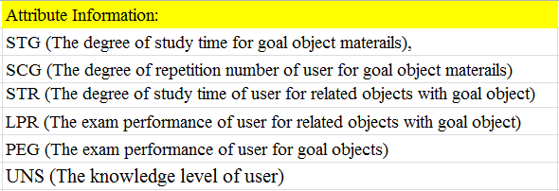

Below, I show the code that I used to execute the K-means for my dataset:

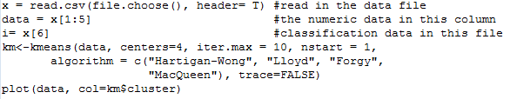

Here, we can see the results of executing the k-means code. The first part is the location of each cluster center for each dimension. The second part attributes each row to one of the four clusters. The third part measures the error, and the fourth part shows the options available for the object we have just created.

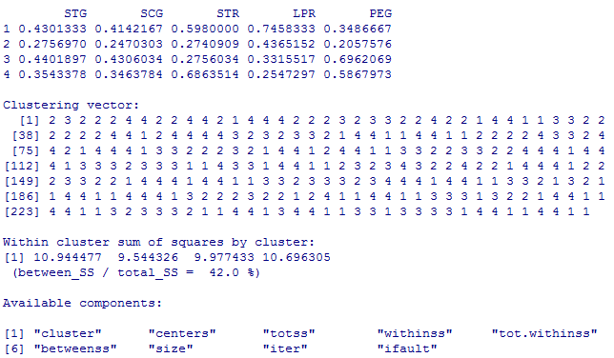

Below, we have the plot of the k-means cluster. Because the data set we have chosen is 5 dimensional, and computer screens are 2 dimensional, we plot the graph in such a way that each attribute is plotted against the other. We can see that some dimensions are more correlated than the others, yet none of the dimensions present the full picture.

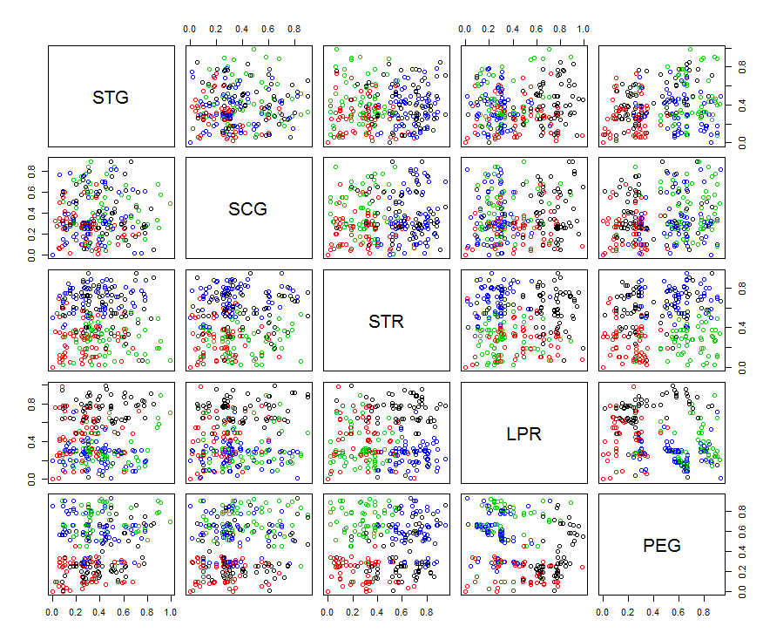

**Question 2:** RoboMe and Watch App

Create a RoboMe and Watch App that uses weather or any API of choice.

**Description:**

**Screenshots:**